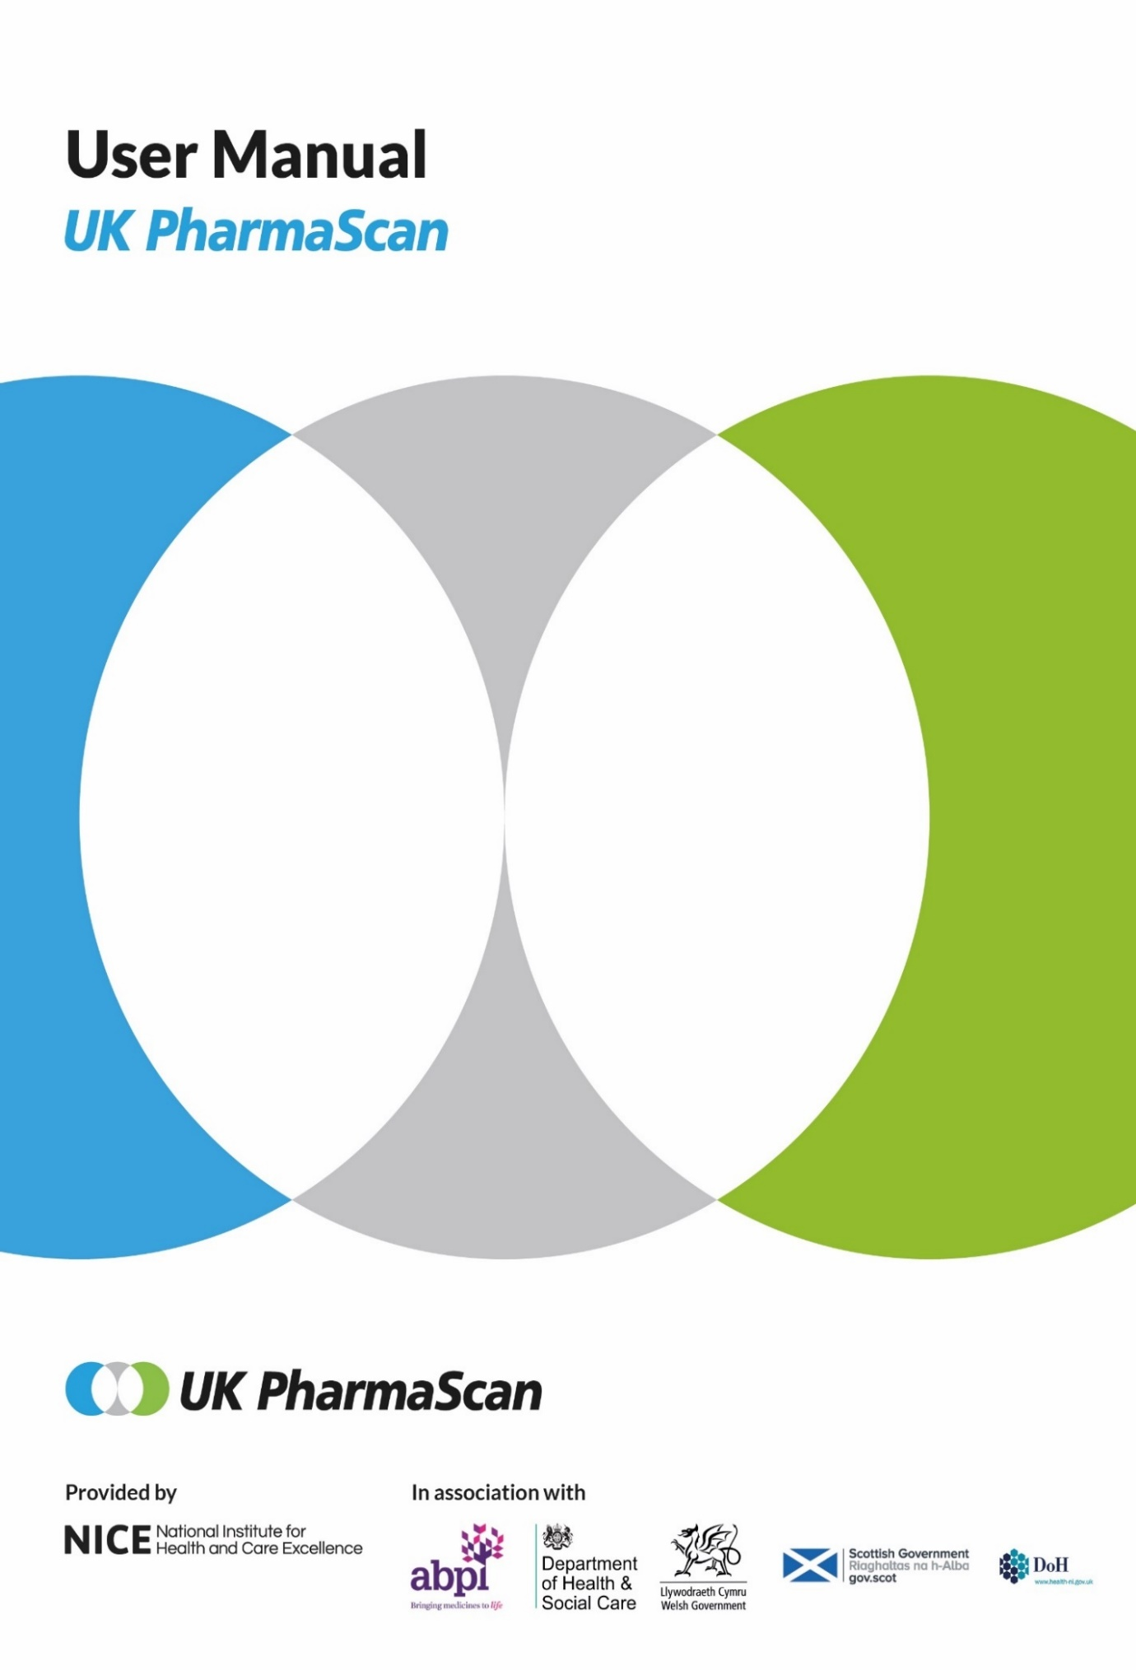

1 Introduction 4
1.1 About UK PharmaScan 4
1.2 About this user manual 4
1.3 Further information and help 5
2 Registration 6
2.1. Registering your company and assigning a Champion User 6
2.2. User Agreement 8
2.3. Standard Users 8
2.4. Activation 10
3 Using UK PharmaScan 12
3.1 Login 12
3.2 Lease issues 13
3.3 Site navigation 14
3.4 Logout 15
4 Drug records 16
4.1 Adding drug records 16
4.2 Viewing and editing drug records 17
4.3 Deleting drug records 17
5 New technology records 19
5.1 Creating technology records 19
5.2 Adding technology records 20
5.3 Commercial in confidence fields 21
5.4 Requesting new dropdown values 21
5.5 Drug 23
5.6 Indication 23
5.7 Formulation 24
5.8 Details 24
5.9 Clinical trial information 25
5.10 Regulatory Information 25
5.11 Cost and budgets 31
5.12 Saving the record 34
6 Clinical trials 37
6.1 Adding clinical trials 37
6.2 Deleting clinical trials 39
7. Viewing and searching for technology records 40
7.1. Viewing technology records 40
7.2. Searching for technology records 41
8. Editing, copying, deleting and archiving technology records 43
8.1. Editing technology records 43
8.2. Copying records 44
8.3. Mark as no change 44
8.4. Deleting technology records 45
8.5. Suspending and archiving technology records 46
9. Quality Assurance 47
9.1. Submitting records to QA 47
9.2. Records submitted in error 48
10. Horizon scanning use of UK PharmaScan 49
10.1. Horizon scanning access 49
10.2. Running a horizon scanning Access Report 50
11. Champion User Administration 51
11.1. Company administration area 51
11.2. Managing user requests 51
11.3. Managing users 52
11.4. Managing Company Details 53
Appendix 1: UK PharmaScan - Fields 55
Appendix 2: UK PharmaScan – Dropdown response options 70

Introduction

About UK PharmaScan

UK PharmaScan has been designed to help the NHS better plan for the introduction of new medicines, indications and formulations, in order to support their faster adoption by the NHS.

It is the primary source of information used by all of the UK’s national horizon scanning organisations and NHS England to enable early engagement in planning and preparing the NHS for the introduction of new medicines, and to support faster NHS adoption.

UK PharmaScan should contain information on your new medicines, indications and formulations which are in phase III clinical trials or three years before UK availability, whichever is earlier. Enter those medicines closest to launch first.

UK PharmaScan is a secure and confidential platform. Data you enter in UK PharmaScan are only accessible to the registered users for your company and the national horizon scanning organisations. Robust web security safeguards are in place and all organisations are covered by the confidentiality clauses in their signed User Agreements.

About this user manual

This user manual is for pharmaceutical companies. All descriptions and screenshots are accurate at date of production but may differ slightly from what you see when using the live service.

The user manual provides getting started information for new users covering:
- registration (section 2)
- tips for navigating round the website (section 3)
- the creation of drug record (section 4), the technology records (section 5) and adding clinical trial information (section 6)
- how to view and search records (section 7)
- how to edit and copy records (section 8)
- submitting records for quality assurance (section 9)
- how horizon scanning organisation use UK PharmaScan (section 10), and
- help for Champion Users to manage the users and company details for your company (section 11).

Appendix 1 lists all the fields and help text featured in UK PharmaScan.
Appendix 2 lists the dropdown response options.

Further information and help

More information on UK PharmaScan can be found on the following sections of the UK PharmaScan website:

- Using UK PharmaScan provides answers to commonly asked questions and includes links to the UK PharmaScan flyer and slide deck.
- Resources contains supporting information including the Information Leaflet, Overview presentation, a skeleton Standard Operating Procedure and examples of ideal records.

The UK PharmaScan enquiries team is based at the National Institute for Health and Care Excellence (NICE) and is available to users from 9am to 5pm Monday to Friday. If you have an enquiry you can contact the team at contactus@ukpharmascan.org.uk.

Registration

Registering your company and assigning a Champion User

At registration stage all pharmaceutical companies are required to select an appropriate person to be the Champion User.

The Champion User is the senior user within a company responsible for registering the company with UK PharmaScan and has the authority to review, approve and maintain access permissions to other users (Standard Users) in that company. A maximum of 5 active users including the Champion User are allowed at any one time.

The Champion User is responsible for:
- granting access to up to 4 other Standard Users
- deactivating a user when they leave or move roles and no longer require access
- assigning a new Champion User when they are on annual leave/extended leave, change role or leave the company.

If you are not your company’s Champion User go to section 2.3.

If you are the Champion User, to register your company:

- Check if your company is already registered by reviewing the dropdown list of companies on the UK PharmaScan registration page.

- To register your company go to the UK PharmaScan website and click Sign in / Register in the top right of the screen.

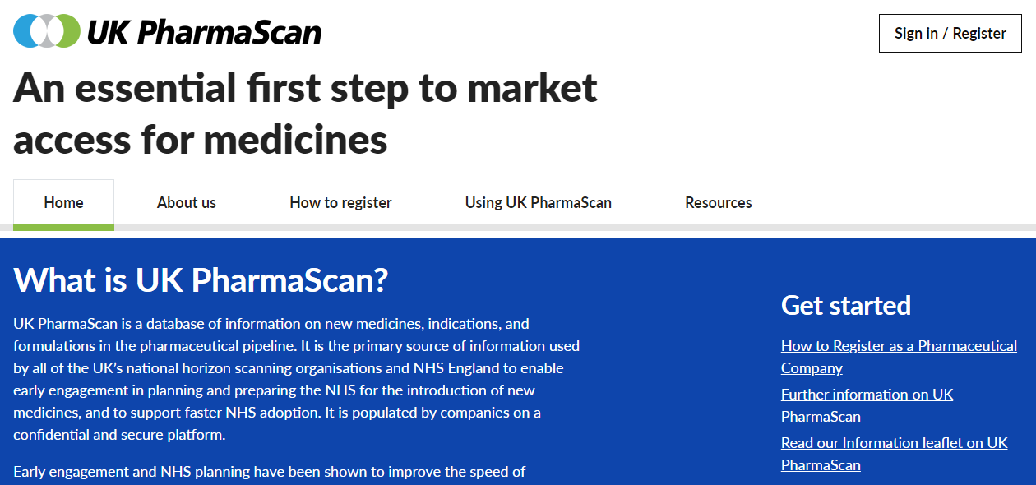

- Select Register your company / organisation and click Register.

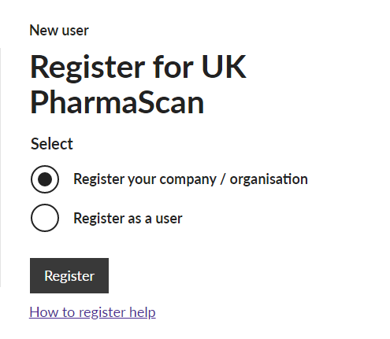

- Complete the registration details and click Register.

After you have submitted the registration form, the UK PharmaScan authorising body for pharmaceutical companies, the Association of the British Pharmaceutical Industry (ABPI) will be asked to approve the proposed company and Champion User. This process takes two to three working days.

You will see a message telling you that your request has been sent for approval.

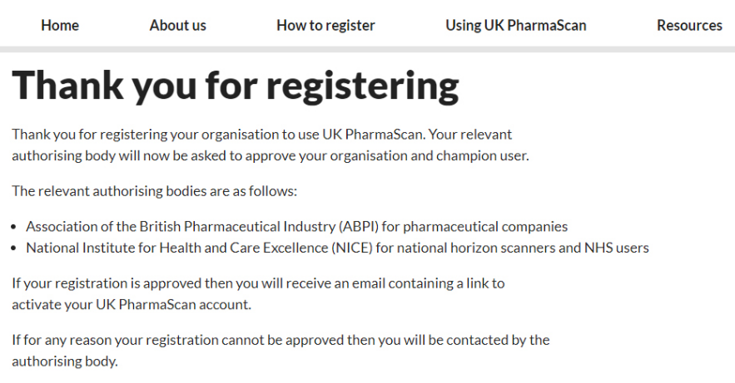

The ABPI will send an email to the Champion User with a link to activate their UK PharmaScan account (section 2.4). Although the Champion User can start to enter data after registration, no data will be published until a signed User Agreement has been received (section 2.2).

User Agreement

If your application is successful you will receive an email from ABPI sent on behalf of the Department of Health including a copy of the User Agreement (Data Inputter).

The User Agreement is a legal agreement between the Secretary of State for Health acting through the Department of Health and your company. The agreement includes details on:
- Registration and provision of the service
- Data and proprietary rights
- Conditions of use
- Intellectual property rights acknowledgement
- Representations and warranties
- Limitation of liability
- Freedom of Information Act
- Data protection and confidential information.
The Champion User is responsible for arranging signature of the User Agreement. Print 2 copies to be signed by a senior person in the company with the authority to act on behalf of and to bind the company to the terms of the agreement.
One signed copy should be retained for your records, the second copy should be sent to NICE – see User Agreement for full address.

Standard Users

Once a Champion User has activated their account, other members of the same company can apply for access to UK PharmaScan as Standard Users.

- To register as a user go to the UK PharmaScan website and click Sign in / Register in the top right of the screen.

- Select Register as a user and click Register.

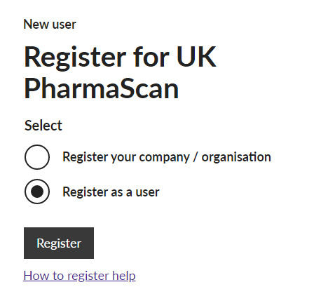

- Select your company from the company / organisation list.

If your company is not listed, it has not yet been approved and/or the Champion User has not activated their account. You will need to wait until the Champion User has activated their account before you can register as a Standard User.

- Complete the registration details and click Register.

You will see a message advising you that your request has been sent to your Champion User for approval.

Your request will automatically be submitted to your company’s Champion User, who is responsible for reviewing and approving your application.

Activation

If your application is successful, you will receive an activation email which contains a link to activate your account. As part of the activation process you will need to download a lease onto your PC. This lease is used to verify that you are an approved user of UK PharmaScan when you login to the site from your PC in the future.

- Click on the activation link in the email.

The activation link will take you to the UK PharmaScan site where you can download your lease.

- Enter your details in the Username (email address) and Password fields.

- Click Login.

You will receive confirmation that your details have been accepted and you will be automatically redirected to download your lease.

Once your lease has been downloaded you will be presented with a confirmation message.

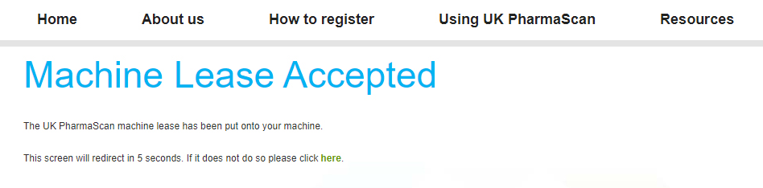

You will then be automatically redirected to your own homepage (section 3).

If you have any problems activating your account or downloading the lease contact the UK PharmaScan enquiries team at contactus@ukpharmascan.org.uk.

Using UK PharmaScan

Login
Once you have registered for UK PharmaScan and downloaded your lease, you can access the site by logging in with your username and password.

- To log in go to the UK PharmaScan website and click Sign in / Register in the top right of the screen.

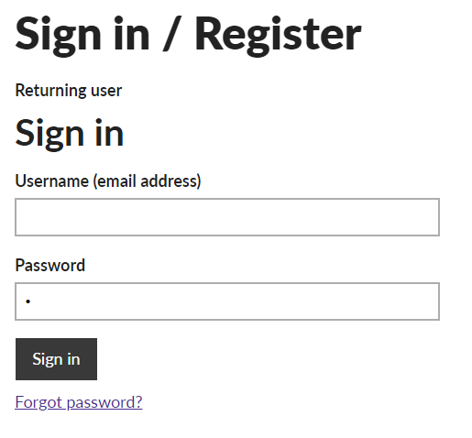

- Enter your details in Username (email address) and Password fields and click Sign in.

You will be taken to your homepage (section 3).

- If you have forgotten your password, click Forgot password?

- Enter your email address and click Submit.

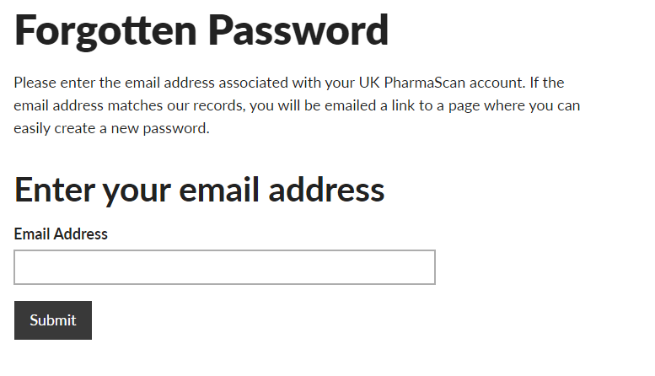

You will be sent an email containing a link where you can reset your password.

Lease issues
If you use a different internet browser, delete your cookies (which store your lease information) or if your Flash software is updated, your lease will be deleted and you will not be able to log in.

If you try to log in, you will be presented with a message telling you that no machine lease has been issued.

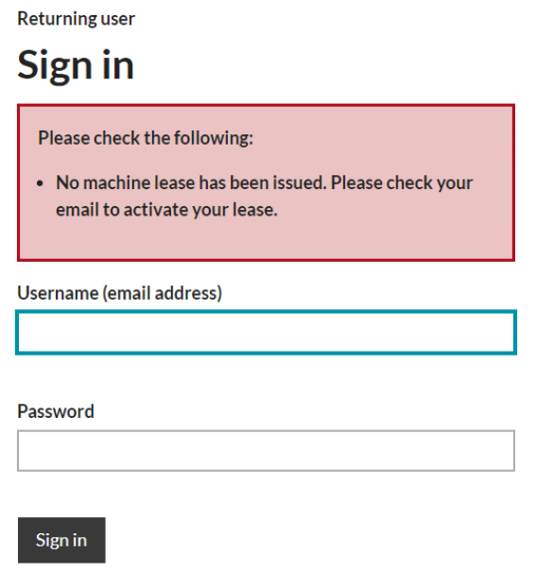

An email will be automatically sent containing instructions to download a new lease.
If you have any problems activating your account or downloading the lease contact the UK PharmaScan enquiries team at contactus@ukpharmascan.org.uk.

Site navigation
After logging in to UK PharmaScan, you will be taken to your homepage via a redirect page.

If you are not redirected automatically, click on click here to go to your home page.

In the top right corner of your homepage, you will see your account details under My Account.

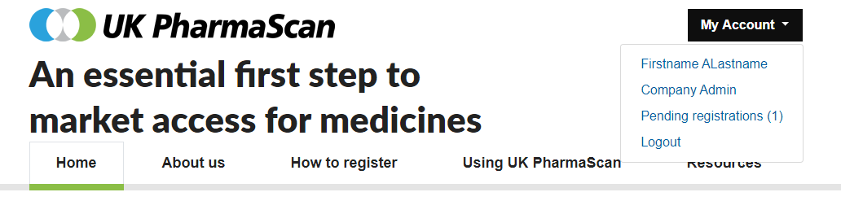

This provides access to your profile information by clicking on your name, the company profile information under Company Admin (Champion User only; section 11), any Pending registrations and the link to Logout (section 3.4).

Below that you will find the following tabs:

- Home page
- About us: information on the management and funding of UK PharmaScan
- How to register: frequently asked questions on the registration process
- Using UK PharmaScan: Questions and Answers on key areas of using UK PharmaScan including entering data, deleting and archiving records
- Resources: overview information on UK PharmaScan in a leaflet and PowerPoint format and products to help use UK PharmaScan including a Product template, Case studies and Example records.

The main body of your homepage is made up of two sections.

In the Search and Action Panel you can search for records (section 7.2), add new drugs (section 4) and technologies (section 5) and run a horizon scanning access report (section 10.2).

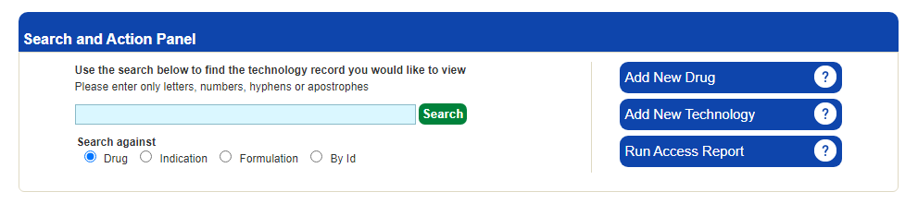

The lower section contains four tabs:
- Technology Records
- Archived Technology Records
- Drugs List
- Search Results.
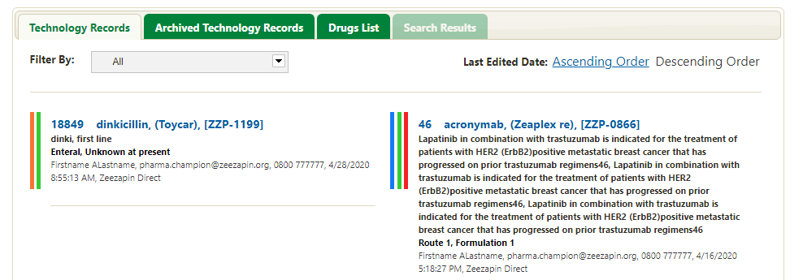

The default view is the Technology Records tab.

Logout

- To Logout, click My Account in the top right of the screen and select Logout.

Drug records

As there can be multiple indications and licensing applications for a single drug, information is held in UK PharmaScan in two separate but linked records:

- A drug record which holds basic information about the name of the drug
- A technology record which holds the information on the indication, licence extension and/or formulation which is subject to the individual licensing application (section 5).

Adding drug records

A drug record must be entered before a technology record can be entered.

- Click Add New Drug.

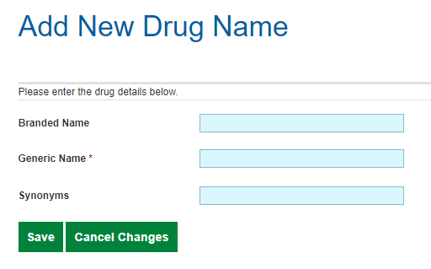

- Complete the details and click Save.

NB: the Generic Name field is mandatory. It is not possible to save a record if the field is not completed.

If a new UK PharmaScan record is created for medicines given in combination, you should ensure that all non-proprietary drug names are entered into the Generic name field. This will help horizon scanning organisations to differentiate medicines given as monotherapy from those given in combination.

Once you have saved the drug record, you can add an associated technology record (section 5).

Viewing and editing drug records

All drugs entered by your company are listed in the Drugs List in alphabetical order.

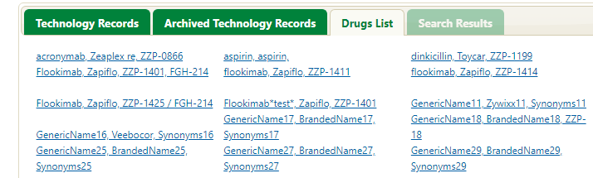
- To view a drug, click the drug name.

- To edit a drug record, then click Edit Drug on the right hand side of the screen.

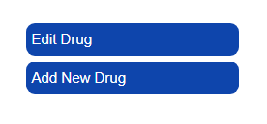

- Edit the record.

- Click Save.

Deleting drug records

Records cannot be permanently deleted from UK PharmaScan. If you have entered data incorrectly on a drug record which has not yet been saved and you have other drugs to enter, you can reuse the record by editing it (section 4.2).

If you cannot re-use the drug record, you should edit the record to tell users in your company that the record is to be ignored by entering ‘ENTERED IN ERROR’ in the Generic name field.

New technology records

As there can be multiple indications and licensing applications for a single drug, information is held in UK PharmaScan in two separate but linked records:

- A drug record which holds basic information about the name of the drug (section 4)
- A technology record which holds the information on the indication, licence extension and/or formulation which is subject to the individual licensing application.

This section covers creating and completing the technology record including guidance on completing the fields. Further useful information is in Appendix 1 which lists all the fields, identifying those that are mandatory, and the help text featured in UK PharmaScan, and the Product Template available on the Resources section of the UK PharmaScan website which lists all the fields with further helpful information for record completion.

Some fields in UK PharmaScan have help text to support their completion. To see the help text click on the ? icon on the right hand side of the field. All the help text is listed in in Appendix 1.

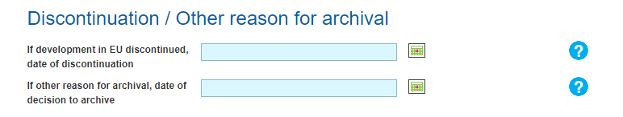

Creating technology records

Companies are asked to create and update technology records in a timely manner and avoid retrospective completion of estimated date fields.

Records should be updated continuously with any new information. Changes to regulatory information should be updated immediately as this information is pivotal to NHS planning for the introduction of new medicines, indications and formulations and scheduling for health technology appraisal.

An automated email advising the record is due for review is sent 3 months after a record was last updated or marked as no change (section 8.3).

A new record must be created for each new product or indication. Existing records should not be re-used as each record has a unique record ID number used by horizon scanning organisations. Existing records which are no longer required can be archived (section 8.5).

Records should not be created retrospectively after a drug has already been launched. UK PharmaScan is not intended to be a source of information on products on the market in the UK.

If the product has multiple indications, or an existing drug has a new indication, create a new technology record for each indication. Each technology record should only have one indication unless it is a biosimilar. To save time copying records you can use the Copy (New Indication) function (section 8.2).

Adding technology records

- Click Add New Technology in the Search and Action Panel on your homepage.

The Add A Technology page will be displayed. This is made up of 7 sections:
- Drug
- Indication
- Formulation
- Details
- Clinical trial information
- Regulatory information
- Cost and budgets.

NB: the technology record must be saved before clinical trial details can be added (section 6).

- To open a section, click the arrow on the right-hand side.

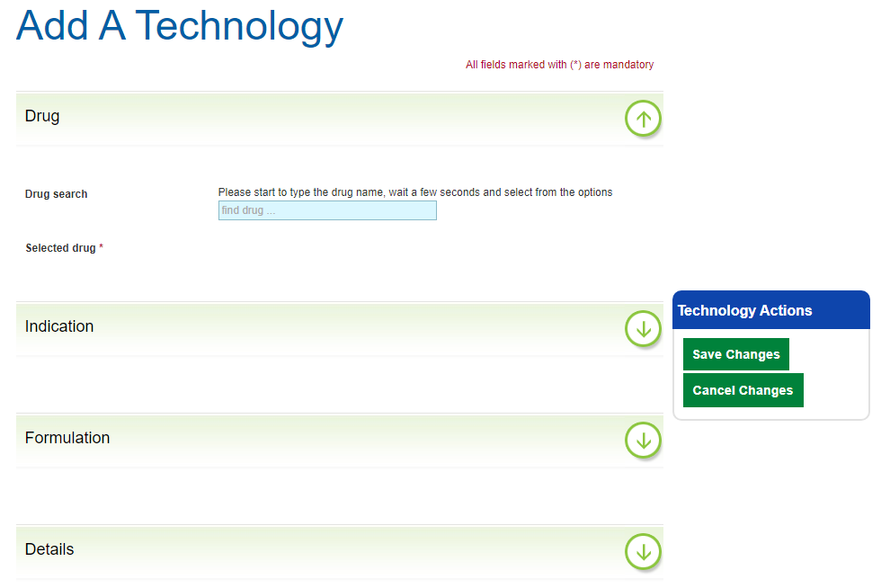

- Enter as much data as possible.

Commercial in confidence fields
Fields where the data are regarded as commercial in confidence are identified in UK PharmaScan by a key icon.

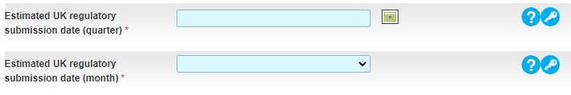

By signing the User Agreement, horizon scanning organisations agree to the principles by which this confidential information can be used to support NHS planning for the introduction of new medicines. Further information can be found in section 10.

Requesting new dropdown values

Appendix 2 lists the current approved dropdown response options.
For fields with dropdown response format where the existing list of values is not comprehensive, new values can be requested using the Request new value function.

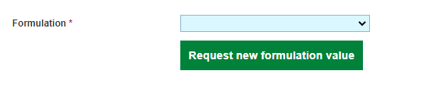

- Click Request new value.

- Enter your suggestion in the panel.

- Click Submit your request.

These requests are reviewed quarterly by the UK PharmaScan User Group, which includes representatives from industry and the national horizon scanning organisations.

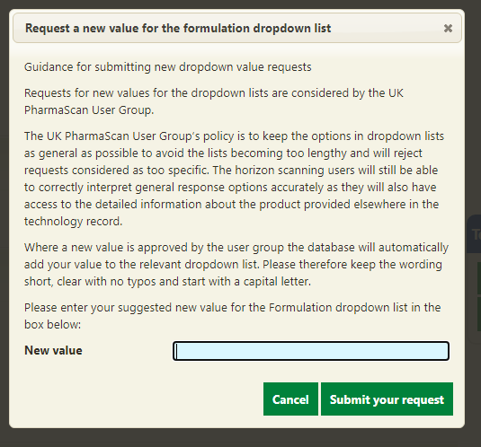

New values approved by the User Group are automatically added to the relevant dropdown list exactly as they are suggested. You should therefore keep your suggestion short, clear and free of typos.

Depending on when you submit your request, it can take up to 3 months for you to find out if it has been accepted. If your request is rejected, you will be told which existing option you should use instead.

Drug

The drug section should already be open when you first open the technology form.

- Enter an existing drug name into the search box in the Title field. Start typing the drug name and a list of possible drug name records will be displayed.

- Select the relevant drug.

This will link the technology record to the drug record. If the search does not retrieve the drug you need you will need to add a new drug record (section 4).

Indication

NB: the Proposed, Abbreviated and Proposed place in therapy fields are mandatory. It is not possible to save a record if they are not completed.

Field | Guidance
Proposed | Mandatory field. State in full the anticipated indication.
Final | State in full the final licensed indication.
Abbreviated | Mandatory field. This field rather than the proposed indication field is displayed in search results.  Briefly state:  - the specific disease name,  - patient population, receptors and/or genes,  - other medicine(s) to be used in combination, if appropriate.  If the drug has multiple indications, look at the other records, and make sure users can easily distinguish between records. Adding trial name may help.
Identified sub groups | Complete if relevant.
Proposed place in therapy | Mandatory field. State the line of therapy the drug will be used in.
Stage of disease | Especially relevant for oncology.
Is paediatric | Specify if the indication is for children or not. Create a separate technology record if there is also an adult indication.

Formulation

NB: the Formulation field is mandatory. It is not possible to save a record if the field is not completed.

If you cannot find an appropriate option from the dropdown list, you can use the dropdown value ‘Other’ and provide details in the If other, please specify free text field, or request a new formulation value by clicking Request new Formulation Value.

Details

NB: the Technology status, Route and Is there a companion diagnostic test? fields are mandatory. It is not possible to save a record if they are not completed.

Field | Guidance
Mode of action | Include the pharmacological class.
Technology status | Mandatory field.
Nature of SPC amendment | Specify the section of the Summary of Product Characteristics (SPC) and state the change in full.
Route | Mandatory field.
Presentation | Complete with relevant detail.
Proposed dose / dosing regime | Complete with relevant detail.
BNF Chapter | Select relevant BNF Chapter from dropdown list
Disease state | Search and select from the disease ontology. List available on request. Select the most specific term that covers the indications included in the licence application. Only use a more general term if no more specific term is available.
Is the drug considered a personalised medicine? | Indicate if the drug’s use takes account of a person’s genes, health, and environment.
Is there a companion diagnostic test? | Mandatory field.
Companion diagnostic test | Give details where relevant.
Current treatment options | Complete with relevant detail.
Likely comparators | For UK HTA purposes
Has this medicine been formally selected for an AWMSG TDA? | Provide any additional information under the associated ‘Comments’ field.
Has this medicine been formally selected for a NICE HTA? | Provide any additional information under the associated ‘Comments’ field.
Will this medicine be appraised by the SMC? | Provide any additional information under the associated ‘Comments’ field.
Who is the originator company / Originator company name | Where the originator company is different from your company, you can select from a list of companies registered with UK PharmaScan. If the originator company does not appear in the list, select ‘Other’ and type the name in the ‘Originator company name’ box.
Is the drug being co-marketed / Co-marketed company | You can select from a list of companies registered with UK PharmaScan. If the co-marketing company does not appear in the list, select ‘Other’ and type the name in the ‘Co-marketed company name’ box.

Clinical trial information

Guidance on adding clinical trials is available in section 6. To add clinical trial information, you must save the record first. If you start working on a clinical trial without saving the main record, you will lose any changes made.

Regulatory Information

Regulatory information on UK and EU processes, including International Recognition Procedures, can be added to the record. Only information relevant to UK horizon scanning organisations for planning and commissioning needs to be captured.
NB: the following fields are mandatory. It is not possible to save a record if they are not completed.
- MHRA regulatory procedure
- MHRA orphan drug status
- Estimated UK regulatory submission date (quarter/month)
- Estimated UK licence date (quarter/month)
- Estimated UK availability date (quarter/month)
- Current EU stage of development
- Orphan drug status in EU.

Field | Guidance
MHRA status
MHRA regulatory procedure | Mandatory field. Select regulatory procedure from the drop-down list including international recognition procedures. For the latest information on the MHRA regulatory procedures please see MHRA website.  If an International Recognition Procedure with a non-European reference regulator is selected in the MHRA regulatory procedure field, the regulatory information in the International Status (IRP and pre-IRP EU) subsection will relate to that non-European reference regulator.  In such cases, the information in the EU status subsection will describe any additional regulatory activity happening within the EU and the EU stage does not need to match the regulatory information in the International Status (IRP and pre-IRP EU) subsection.  If “International Recognition Procedure – European Union as reference regulator” or a pre-IRP EU reliance procedure is selected in the MHRA regulatory procedure field, the regulatory information in the International Status (IRP and pre-IRP EU) subsection will relate to regulatory activity within the EU.  In these cases, the information in the EU status subsection should match the rest of the regulatory information in the International Status (IRP and pre-IRP EU) subsection.
MHRA regulatory procedure details | Complete any additional details to support the MHRA regulatory field above.
Estimated UK regulatory submission date (quarter/month) | Mandatory field. Complete both quarter and month fields. Where the month is not yet known, use the ‘unknown’ option.
Estimated UK licence date (quarter/month) | Mandatory field. Complete both quarter and month fields. Where the month is not yet known, use the ‘unknown’ option.
UK conditional approval anticipated | Conditional approval is based on reduced clinical data, valid for 1 year (can be renewed) with obligation for ongoing studies.
Estimated UK availability date (quarter/month) | Mandatory field. Indicate when the product is estimated to be available in the UK for supply against a prescription.  Complete both quarter and month fields. Where the month is not yet known, use the ‘unknown’ option.  Where there is no launch date available at the time a licence is granted, an estimated date should still be entered in this field.
Actual UK regulatory submission date | Date on which regulatory dossier was sent to the regulatory agency. Date must less than ‘Actual UK licence date’ and ‘Actual UK availability date’.
Actual UK licence date | Date on which licence is granted.
Actual UK availability date | This is the date on which the product is made available in the UK for supply against a prescription.  The technology record will be archived 90 days from this date.
MHRA Promising Innovative Medicine (PIM) designation granted? | The Early Access to Medicine Scheme (EAMS) is a voluntary MHRA regulated process that allows patients in the UK access to drugs intended for life-threatening or seriously debilitating conditions that do not yet have a marketing authorisation when there is a clear unmet need. It is a two-stage evaluation process. Step I involves receiving a Promising Innovative Medicines (PIM) designation. This will give an indication that a drug may be eligible for EAMS based on early clinical data.  If a drug is not going through the EAMS process, or receives a negative PIM designation, then this field should be marked as ‘No’.
Estimated Early Access to Medicines Scheme (EAMS) submission date | For products that have been awarded a PIM designation, an EAMS submission can be completed for MHRA consideration. Where possible indicate the anticipated EAMS submission date using this field.
Actual EAMS submission date | Complete the actual date once submission has been made.
Estimated EAMS scientific opinion date | MHRA issues a scientific opinion on the benefits/risk balance of the drug. The opinion (which lasts for 1 year and can be renewed) supports the prescriber and patient to make a decision to use the drug before its licence is approved and does not replace normal licensing procedures.
Actual EAMS scientific opinion date / EAMS scientific opinion decision | Complete the actual date once the opinion has been received. Include both the decision outcome and update the final wording regarding anticipated licence and population in the relevant fields.
International Status (IRP and pre-IRP EU)
Estimated International regulatory submission date (quarter/month) | Complete both quarter and month fields. Where the month is not yet known, use the ‘unknown’ option.
Estimated International licence date (quarter/month) | Complete both quarter and month fields. Where the month is not yet known, use the ‘unknown’ option.
International Fast Track application anticipated | This should relate to the International Reference Regulator that you selected in the MHRA regulatory procedure field.
International conditional approval anticipated | This should relate to the International Reference Regulator that you selected in the MHRA regulatory procedure field.
Actual International regulatory submission date | Date on which regulatory dossier was sent to regulatory agency. Date must less than ‘Actual International licence date’. This should be the date you filed an application for a licence to the International Reference Regulator that you selected in the MHRA regulatory procedure field.
Estimated International opinion date | If applicable, this should be the date you estimate a recommendation to approve a licence will be issued by the International Reference Regulator that you selected in the MHRA regulatory procedure field, e.g. EMA CHMP opinion date.
Actual International opinion date | Indicate the actual opinion date. Prompt completion is essential for horizon scanning organisations managing the entry of new products into the NHS as it provides a specific timeframe for the issue of a marketing authorisation. Many horizon scanning organisations will use the CHMP opinion date, for example, as a prompt for active planning. Update ‘Current EU stage of development’ field if relevant.
International opinion | Complete details of the actual opinion (positive, negative etc.) and amend the estimated licensing date fields if necessary.
Actual International licence date | This should be the date a licence is issued by the International Reference Regulator that you selected in the MHRA regulatory procedure field.
EU Status
Current EU stage of development | Mandatory field.  Phase I  The product is the subject of a Phase I clinical trial but no Phase II or III trial has yet been started.  Phase II  The product is the subject of a Phase II clinical trial but no Phase III trial has yet been started.  Phase III  The product is the subject of a Phase III clinical trial (possibly in parallel with a continuing Phase II trial) but no regulatory application has been made in the EU or a member state.  Pre-registration  A regulatory dossier has been filed with the European Medicines Agency, the MHRA or the national regulatory body of another member state, but a CHMP Opinion has not been issued and no marketing authorisation has been granted. Must be selected if a regulatory dossier has been submitted, even if Phase II or Phase III trials are ongoing.  CHMP Opinion  For products following the EU Centralised route, the Committee for Human Medicinal Products of the EMA has issued an Opinion on the product (positive or negative), but the EMA has not yet granted a marketing authorisation.  Licenced in member state  The product has received a marketing authorisation from the MHRA or the regulatory body of another member state, but has not yet been granted a marketing authorisation by the EMA under the Mutual Recognition procedure and has not yet been launched on the market in the UK.  Approved in EU  The product has been granted a marketing authorisation by the EMA, either under the Centralised or the Mutual Recognition procedure, but has not yet been launched on the market in the UK.  Available in UK  The product has received a marketing authorisation valid in the UK from either the EMA or the MHRA, has been launched on the market in the UK and may be prescribed within the product licence for the relevant indication and patient population.
EU regulatory procedure | Select the regulatory process being followed.  EU Centralised  This procedure results in a single marketing authorisation (called a 'Community marketing authorisation') that is valid across the European Union, as well as in Iceland, Liechtenstein and Norway. The centralised procedure is compulsory for human medicines that are: derived from biotechnology processes, such as genetic engineering; intended for the treatment of HIV/Aids, cancer, diabetes, neurodegenerative disorders or autoimmune diseases and other immune dysfunctions; officially designated 'orphan medicines' (medicines used for rare diseases).  EU Decentralised  The decentralised procedure enables a marketing authorisation for a medicinal product to be obtained in several Member States where it has not yet received a marketing authorisation at the time of application. The procedure varies depending on who initiates it, a Member State or the marketing authorisation holder.  EU mutual recognition  In the mutual-recognition procedure, a medicine is first authorised in one EU Member State (known as the reference member state),. Following this, further marketing authorisations can be sought from other EU countries in a procedure whereby the countries concerned agree to recognise the validity of the original, national marketing authorisation.
US status
Development in the US / Response letter issued / Date | Use these fields to provide details on whether the product has already been developed in the USA. Response letter issued, refers to the complete response letter issued by the US Food and Drug Administration.
FDA fast tracked | Complete if relevant.
FDA orphan drug status | Complete if relevant.
Orphan Drug / ATMP categorisation
MHRA orphan drug status | Mandatory field.
Date MHRA orphan drug status granted / number | Complete details if answered ‘Yes’ to ‘MHRA Orphan drug status’.
Orphan drug status in EU | Mandatory field.
Date EU orphan drug status granted / number | Complete details if answered ‘Yes’ to ‘Orphan drug status in EU’.
Classified as an Advanced Therapy Medicinal Product (ATMP) in EU / ATMP classification / Date of recommendation on classification of ATMP | Advanced Therapy Medicinal Product (ATMPs) are medicines that are based on genes, tissues or cells. All advanced therapy medicines are authorised centrally via the European Medicines Agency (EMA). They benefit from a single evaluation and authorisation procedure.  If the EMA has agreed that the medicine is an ATMP, add the ATMP classification and the date that the decision was made.  If the EMA agrees the medicines is not an ATMP or cannot conclude on the classification of this product, this question should be marked as ‘No’.  If the EMA has not considered the question of whether a medicine is an Advanced Therapy Medicinal Product (ATMP) all the ATMP fields can be left blank.
MHRA / international regulator Withdrawal, Suspension of Discontinuation status
Withdrawal date / Reason / Are there further plans for trials / refiling? | If the product has been withdrawn add date, reason and if there are any plans for new trials or refiling.
Suspension / Discontinuation / Archival | Use these fields if development of the product has been suspended, discontinued or if it is necessary to archive the technology record for some other reason (section 8.5). The technology record will be archived 90 days from this date.

When entering the estimated and actual dates for regulatory submission, licence and UK availability, it is important that the dates are entered in logical and chronological order and are kept up to date.

Estimated dates should be in the future when the specified event (for example, regulatory submission date) is expected to occur. For example, the Estimated UK regulatory submission date must be before the Estimated UK licence date, which must be the same or before the Estimated UK availability date. Where estimated dates have passed and actual dates have not been entered the estimated dates should be updated.

Actual dates (including Actual International opinion date) should only be completed when the event has occurred. Again, the dates are to be in a logical order, for example, the Actual UK regulatory submission date must be before the Actual UK licence date, which must be the same or before the Actual UK availability date.

Once actual dates are completed, the equivalent estimated field will appear as strikethrough text online and in pdf reports. For example, when the Actual UK regulatory submission date is completed, the Estimated UK regulatory submission date will appear as strikethrough text. It is not necessary to delete estimated dates when actual dates are completed.

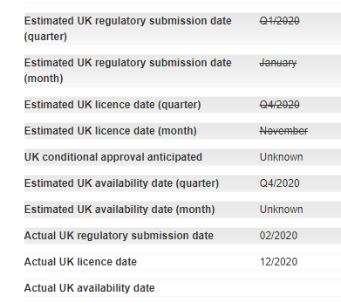

EU regulatory information, added to UKPS prior to the International Recognition Route process and changes to the UKPS introduced in January 2024, will be shown in the fields in the International Status (IRP and pre-IRP EU) subsection.

Cost and budgets

NB: the Drug cost range and UK patient population range fields are mandatory. It is not possible to save a record if they are not completed.

It is acknowledged that providing cost estimates in advance of product launch is challenging and detailed costs may not be available until a few months before launch. This is, however, an essential aspect of horizon scanning processes as the cost projections support the NHS budget setting process (done in advance of the financial year in which the new product is likely to be launched) and ensure sufficient budget allocation.

Field | Guidance
Proposed average dose | Align with dose information given in Details section.
Place in therapy | Select from dropdown options.
Estimated length of treatment | Complete with relevant detail.
Drug cost range | Mandatory field. Provide the drug cost range calculated per patient per year or patient per episode if less than one year. If the ranges are too restrictive, use the ‘Drug Cost Notes’ to enter broader estimates or general information about proposed costing strategies.  Costing estimates made by horizon scanning organisations should not be used to complete technology records.
Drug cost notes | The field can be used to provide details of estimated acquisition cost (or cost range) of the new product and the dosing regimen (or potential dose range) associated with the cost.  Specify what completed drug cost ranges refers to, i.e. whether it is per patient per year or per patient per episode.  If accurate estimates are unavailable, a range, or ‘ball-park’ estimates are acceptable. Indicate if the figures are accurate estimates or ball park figures.  State clearly whether costs include or exclude VAT.
Is a Patient Access Scheme or alternative discount arrangement planned for this indication? | If a Patient Access Scheme or alternative discount arrangement is planned, select for each relevant country.
Is the technology available on a compassionate basis pre-licence in the UK other than clinical trials? | Complete if relevant.
Service impact | Indicate what the potential service impact (other than drug acquisition cost) of the new product may be to the NHS. For example, cost of testing or new equipment associated with its use; impact on staffing or service provision; administration of the drug. It is important to highlight whether the impact is expected to be significant.
Impact on patient and carers | Indicate the potential health impact of the new product, in terms of quality of life and survival. Include such aspects as patient preferences, adherence, and if possible, consider the wider societal health impact of the therapy.
UK patient population range | Mandatory field. Provide the incidence per 100,000, or for long term conditions prevalence per 100,000 or actual patient numbers. Where possible, data at the devolved level is preferential but if data is not known for all 4 regions then UK data should be specified. Reliable sources include guidance from the National Institute for Health and Care Excellence [NICE]) or Scottish data (e.g. epidemiology data from NHS National Services Scotland [NHS NSS] or Health Protection Scotland [HPS]) or Welsh data (e.g. www.infoandstats.wales.nhs.uk) and can be used to extrapolate estimates.  Information on the epidemiology of the condition obtained through a systematic search of the published literature can be used to check the estimates derived from these epidemiological data or may be used instead, if these data are not available.  Where the eligible population is estimated from an extrapolation of figures in published literature, population data should be taken from the latest mid-year population estimates.  Epidemiology and costing estimates made by horizon scanning organisations should not be used to complete technology records.
UK patient population notes | Details should be provided for any complex calculations and any assumptions used in calculating estimated patient population should be outlined.  State reference sources used for epidemiological data.
Estimated eligible patient population | Provides details of the assumptions used to estimate the number of patients who would be eligible for treatment with the new product or licence. Enter details of any factors or issues that create uncertainty around the estimate of eligible population, for example, limitations of data used to estimate mean patient numbers for a rare condition or disease; or potential disparity in the distribution of patients across the UK for rare diseases with a genetic component. State any reference sources used and include details of any complex calculations.
Is the drug likely to have a significant service impact? | If answer ‘Yes’ provide details in the ‘Please specify’ free text field.
Is the net budget impact for the UK greater than £5million at year 5? | If answer ‘Yes’ complete details in the next 4 fields.
Estimated uptake | Provide details of the proportion of the eligible population predicted to receive the new product in the first and fifth full calendar years after it is launched. Enter details of any other assumptions used to estimate uptake, for example, an assumption that the new product would only be given to a sub-group of eligible patients.  Enter details of any factors or issues that create uncertainty around the estimate of uptake of the new product, for example, lack of data on the cost-effectiveness of the new product relative to relevant comparators, the potential for ‘off-label’ use in patients not covered by the indication in the proposed product licence, or proposed clinical guidance that may alter treatment pathways.  State any reference sources used and include details of any complex calculations.
Estimated net incremental drug acquisition costs per annum at year 1 and 5 | Provide the estimated net incremental drug acquisition costs. These are calculated by subtracting the estimated drug acquisition cost per annum of alternative treatment(s) from the estimated drug acquisition cost per annum of the new product.  Enter details of the most common treatment(s) that the new product is likely to replace including dosing regimens. Enter details of the drug acquisition cost of the main treatment(s) that the new product would replace. Details should be provided for the source of costs for the alternative treatment(s) e.g. the most recent version of the BNF (www.bnf.org).  Enter details of any factors or issues that create uncertainty around the estimate of incremental drug acquisition cost, for example, the pending loss of patent protection of an alternative treatment, or the pending launch of a similar new product.  State clearly whether costs include or exclude VAT.
What will be the net budget impact at year 1 and 5? | Provides the net budget impact at year 1 and 5. This is calculated by multiplying the estimated uptake at years 1 and 5 by estimated net incremental drug acquisition cost per annum at years 1 and 5. State clearly whether costs include or exclude VAT.
Budget impact model available from the company on request | Complete if net budget impact for the UK will be greater than £5million at year 5.

Saving the record

When you have entered your data, the record can be saved.
NB: it is not possible to save the record if the mandatory fields have not been completed. These are identified by a red asterisk against the field name.

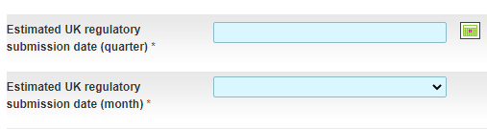

The mandatory fields are:
- Generic name
- Proposed indication
- Abbreviated indication
- Proposed place in therapy
- Formulation
- Technology status
- Route
- Is there a companion diagnostic test?
- MHRA regulatory procedure
- MHRA orphan drug status
- Estimated UK regulatory submission date (quarter/month)
- Estimated UK licence date (quarter/month)
- Estimated UK availability date (quarter/month)
- Current EU stage of development
- Orphan drug status in the EU
- Drug cost range
- UK patient population.

- Click Save changes in the Technology Actions box.

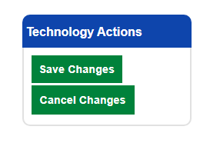

Once you have saved the changes, the page will refresh and the newly created record will be displayed. A unique record ID number will appear next to the Technology Summary heading and you will see options including ‘Edit’ and ‘Submit to QA’.

Once you have saved your record, you can add details of clinical trials (section 6).

NB: once all the known details for a record have been completed click Submit to QA. Records are not published on the website or visible to horizon scanning organisations until they have been submitted to and approved by QA.

Clinical trials

Adding clinical trials
To add clinical trial information, you must save the record first. If you start working on a clinical trial without saving the main record, you will lose any changes made.

- Click the arrow next to Clinical trials information to expand the section.

- Click Add clinical trial.

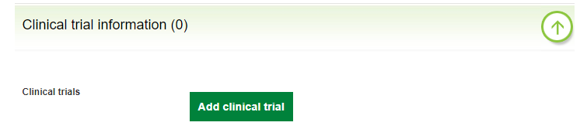

- Complete the Add A Clinical Trial form.

The clinical trial information section should be completed with details of clinical trials used by the company to support its application for a marketing authorisation. Enter a Study Name and the National Clinical Trial number from ClinicalTrials.gov. When the National Clinical Trial number is entered (beginning with NCT) and the record saved, a hyperlink to the corresponding record on the ClinicalTrials.gov website will be automatically generated.

NB: only a valid NCT number will create a link to the corresponding ClinicalTrials.gov record. Any other number or phrase will still create a link but it will open a browser window showing an error message. You can check if the links are working by saving your record (exiting edit mode) and reviewing the information. The Study Name will be displayed in green and will link to the corresponding record on the ClinicalTrials.gov website.

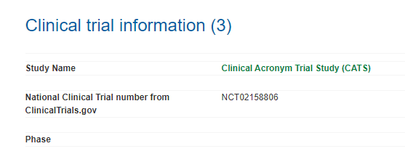

If you do not publish data on the ClinicalTrials.gov website you can enter a trial number from a different registry in the Trial number from other clinical trial registry field or you can add web address links to published trial documents in the Publications field.

NB: horizon scanning organisations use the linked ClinicalTrials.gov record to access the full details of the trial, therefore the full trial information does not need to be duplicated in UK PharmaScan.

Field | Guidance
Study name | Study name – generally include the full name of the trial, plus any acronym or short name. This will become the hyperlink to the ClinicalTrials.gov record, which opens in a separate tab.
National Clinical Trial number from ClinicalTrials.gov | Enter with no spaces, e.g. NCT02101234. Do not enter more than one number or add additional text.
Trial number from other clinical trial registry | If the trial is listed in another clinical trial registry such as the International Standard Randomised Controlled Trial Number (ISRCTN) or the EU Clinical Trials Register (EudraCT) number, the number may also be included here, e.g. ACTRN1262302695. You can add information about the registry if needed, e.g. ACTRN1262302695 (ANZCTR) or add a hyperlink  https://anzctr.org.au/ACTRN1262302695.aspx. Multiple trial numbers can be added into this field if needed but should be comma separated. Field may be left blank.
Publications | List all relevant publications of trial results, including early publications such as company press releases and conference abstracts, although horizon scanning organisations will give more weight to papers in peer-reviewed journals. Include the URL and citation.

- Click Save and then click Submit to QA.

NB: the information entered will not be published and made available to the horizon scanning organisations until you click Submit to QA. Updates to records are not published on the website or visible to horizon scanning organisations until they have been submitted to and approved by QA.

Deleting clinical trials
It is not possible to delete clinical trials from UK PharmaScan. If you have entered a trial incorrectly on a record which has not yet been published and you have another trial to enter, you can reuse the trial fields by editing them.

If you have published the clinical trial information, you should clear all information from the record (it will remember the participating countries field) and enter ‘ENTERED IN ERROR’ in the Study Name field.

Viewing and searching for technology records

Viewing technology records

All technology records are colour coded according to their status.

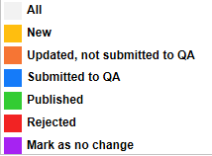

Further information on the Mark as no change status is available in section 8.3.

Records can be filtered by status in the Technology Records tab. By default, records are displayed in Descending Order of the date they were last edited, with the records edited most recently at the top. To change the display order so that the records edited most recently are at the bottom, click Ascending Order.

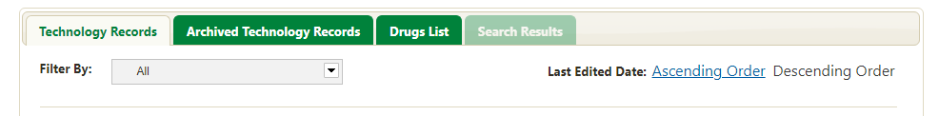

- Click Filter By and select the status you want to view.

- Click the technology record to open it.

The technology record displays all the entered details in the following order:
- Drug
- Indication
- Formulation
- Details
- Clinical trial information
- Regulatory information
- Cost and budgets.

Key dates are displayed at the bottom of each record.

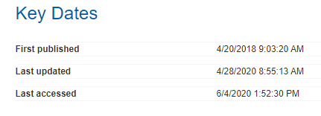

- First published date the technology record was first approved by QA and made visible to horizon scanning organisations
- Last Updated date the record was last edited and approved by QA. This includes when a record has been marked as no change and approved by QA
- Last Accessed date the record was last viewed by pharmaceutical or horizon scanning users.

Audited changes are displayed in the audit history log at the bottom of edited technology records.
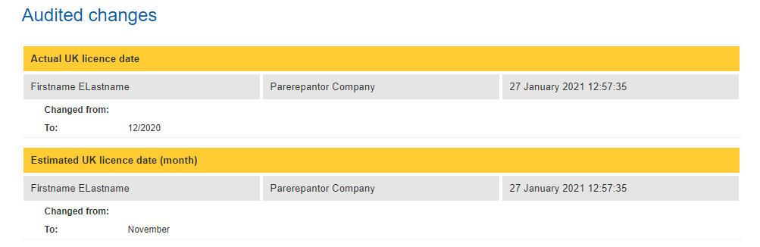
This records the following information for each approved edit, including when a technology record is marked as no change:
- Field
- User name, Pharmaceutical company, Date and time
- Changed from:
- To:.
The audit history log is visible at the bottom of edited technology records both online and in pdf format for pharmaceutical users and online only for horizon scanning users.

Searching for technology records

You can search for existing records by entering relevant search terms into the search box and selecting the field you want to search from:

- Select the field you want to search.

- Enter your search term into the search box.

- Select to search against Drug / Indication / Formulation / Record ID number

- Click Go.

- Click the technology record to open it.

Editing, copying, deleting and archiving technology records

Editing technology records

Records which have the status Submitted to QA cannot be edited.

All other records can be edited.

- To edit a record, click the technology record to open it.

- Click Edit.

- Edit the record.

- Click Save changes in the Technology Actions box on the right-hand side of the screen.

If you are editing an existing record, and want to add or edit a clinical trial, you must save the record first. If you start working on a clinical trial without saving the main record, you will lose any changes made.

When you have made and saved all your changes click Submit to QA so the record can be reviewed, approved and published. Updates to records are not published on the website or visible to horizon scanning organisations until they have been submitted to and approved by QA.

Changes made to a technology record approved by QA are noted in the technology record audit history log.

An automated email will be sent every 3 months after a record was last updated or marked as no change advising the record is due for review. Please check all records and ensure these are up to date.

Copying records

Data can be copied from an existing record into a new record for new indications and new formulations.

- Open the relevant technology record.

- Click Copy (New Indication) or Copy (New Formulation) at the top of the record.

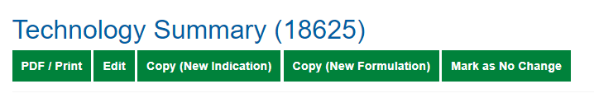

Mark as no change

When a published technology record has not recently been updated, the record status will change to Mark as no change and be colour coded purple. You should review these records every three months to check if they need to be updated.

Records which do not need to be updated should be marked as no change. Records marked as no change are automatically submitted to QA. Records which require updating should be edited (section 8.1) and submitted to QA.

- Filter the records by Mark as no change.

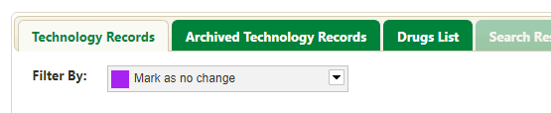

- Open each record.

- Review the record.

- If the record needs updating, edit and save it, and Submit to QA.

- If the record does not require an update, click Mark as no change and the record will then be automatically submitted to QA.

Mark as no change is displayed at the top of every record that has been approved by QA and published and can be clicked at any time. Marking a record as no change is recorded in the technology record audit history log.

An automated email will be sent every 3 months after a record was last updated or marked as no change advising the record is due for review. Please check all records and ensure these are up to date.

Deleting technology records

Records cannot be permanently deleted from UK PharmaScan. If the record has not yet been published and you have other indications to enter, you can reuse the record by editing it (section 8.1).

If you cannot re-use an unpublished record you should edit the record to tell users in your company that the record is to be ignored by entering ‘ENTERED IN ERROR’ into the Abbreviated indication field (which appears on the homepage and in search results).

Unwanted records which have been published should be archived detailing the reason for archival (section 8.5). Published records should not be re-used.

Suspending and archiving technology records

Records which have a date entered in If suspended, date of suspension will be marked as suspended and colour coded grey.

Records are automatically archived 90 days after the date completed in one of the following fields:
- Actual UK availability date
- If development in EU discontinued, date of discontinuation
- If other reason for archival, date of decision to archive.
The records will then appear in the Archived Technology Records tab on the homepage.
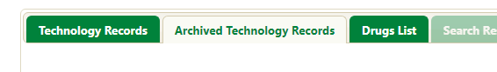
If development of a technology in the EU has been stopped for reasons other than launch, suspension or discontinuation, the date and reason can be completed in the Regulatory information section under Other reason for archival.
Other reasons for archival include:
- Drug is not being taken forward in UK due to commercial reasons
- Drug has been out-licensed to another company
- Rights to drug have been returned to the originator company.
NB: it is not possible to delete records from UK PharmaScan (section 8.4).

Quality Assurance

Submitting records to QA

To ensure quality data entry you can refer to the latest quality assurance (QA) criteria available on the Resources section of the UK PharmaScan website.

When you have entered your drug (section 4) and technology records (section 5) and are ready to make them visible to horizon scanning organisations, you need to submit your records for QA.

- Click Submit to QA.

- Click OK in the pop-up box.

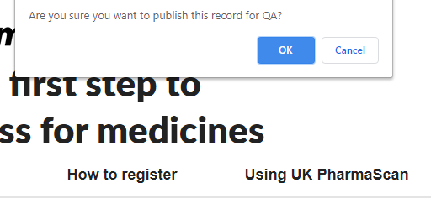

Once submitted to QA the record is colour coded blue and cannot be edited until it has been either approved or rejected by QA. The record will be processed through QA within a few working days.

If the technology record is approved, you will receive an email informing you of this and the record will be published on the website, visible to the horizon scanning organisations. The record status will be automatically changed to Published and colour coded green. Published records can be edited.

If the technology record is rejected, you will receive an email informing you of the reason for rejection. The record status will be automatically changed to Rejected and colour coded red.

A new technology record that has been rejected will not be visible to horizon scanning organisations until the record has been edited in line with the QA comments, resubmitted to QA and approved.

Any edits made to a published record that has been rejected will not be visible to horizon scanning organisations until the record has been edited in line with the QA comments, resubmitted to QA and approved. Until a record is approved by QA, the previously published version will remain visible to the horizon scanning organisations.

Changes made to technology records approved by QA are noted in the audit history log. This can be seen at the bottom of each technology record both online and in pdf format for pharmaceutical users and online only for horizon scanning users.

Records submitted in error

Records are only made available to horizon scanning organisations once they have been approved via QA. If a record is submitted for QA by mistake contact the UK PharmaScan enquiries team at contactus@ukpharmascan.org.uk with the record ID number. The QA team will reject the record for you so you can amend and resubmit it.

Horizon scanning use of UK PharmaScan

Horizon scanning access

All of the UK’s national horizon scanning organisations have access to published records in UK PharmaScan to enable early engagement in planning and preparing the NHS for the introduction of new medicine.
- NHS England and NHS Improvement
- NIHR Innovation Observatory
- NICE
- Specialist Pharmacy Service
- Scottish Medicines Consortium
- All Wales Medicines Strategy Group
- Health and Social Care Board (Northern Ireland).
Horizon scanning organisations are required to sign a User Agreement (Data Accessor) and register a Champion User and Standard Users totalling a maximum of 5 users as detailed in section 2.
The User Agreement (Data Accessor) details how information from UK PharmaScan must only be distributed in advice documents for use by the NHS in a format which either:
- presents only non-confidential information
- presents the data in a format which has been further analysed by the User such that such confidential information is not able to be discovered from reading the document
- clearly identifies any confidential information as such and places restrictions on readers as to the further non-disclosure of confidential information by the reader.

Horizon scanning users can create a ‘Watch list’ of records they are interested in and run the following reports:
- Custom Report to view technology records published by pharmaceutical companies
- Usage Report to show the number of drug and technology records for each company
- Audit Report to show all technology records that have been created or updated between a given start date and end date.

Running a horizon scanning Access Report

The Access Report details when your company’s technology records have been accessed and by which horizon scanning organisation.

- Click Run Access Report in the Search and Action Panel on your homepage.

- Complete the details and click Run Report.

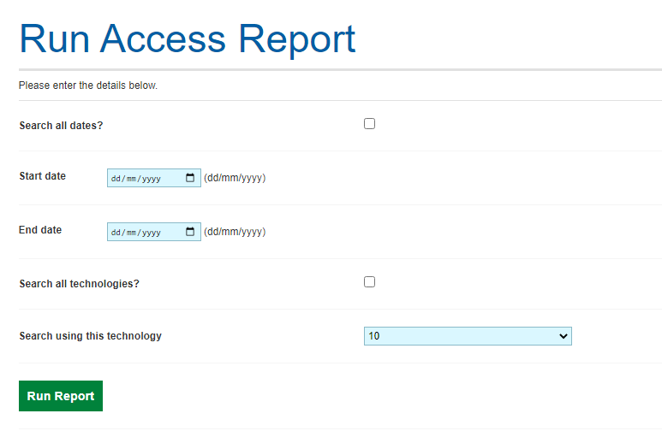

On the search page you can choose to:
- search by a date range or search all dates
- search by a technology or search all technologies.

The report will show the technology record ID, drug name, abbreviated name, horizon scanning organisation and date of access.

Champion User Administration

Company administration area

In the company administration area of the site, Champion Users can:
- Manage pending user requests (section 11.2)
- Manage users (section 11.3)
- Manage company details (section 11.4).

A maximum of 5 active users including the Champion User are allowed at any one time. The QA team will periodically review user numbers and contact companies with more than the maximum number.

- Click My Account in the top right corner of your homepage and select Company Admin.

You will be presented with the Company Administration information.

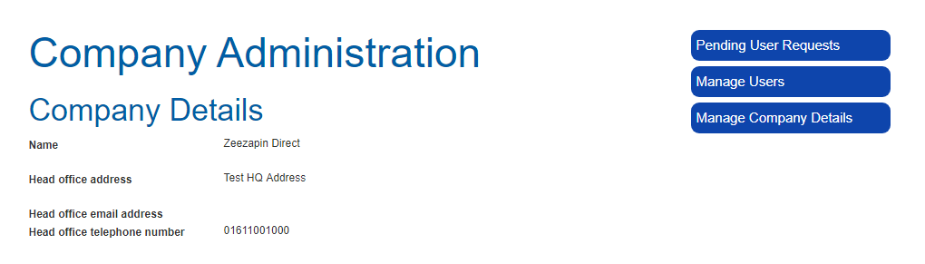

Managing user requests

- Click Pending User Requests and a list of pending user requests will be displayed.

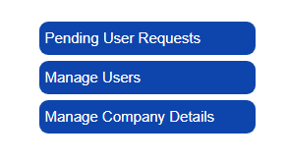

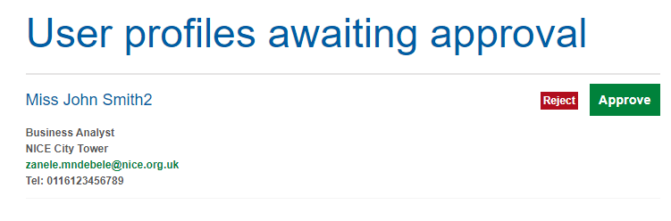

- To approve a request, click Approve next to the user details.

The system will automatically create a profile for the user in the system and send the user an activation email.

- To reject a request, click Reject next to the user details.

The system will register the request and rejection in an audit log.

Once you have approved or rejected a request, the user record will be removed from the User profiles awaiting approval list.

Managing users

If you leave your company or go on extended leave, you need to allocate a new Champion User using the Manage Users function. You can also use this function to activate or deactivate other users’ accounts. If you deactivate a user’s account they will be unable to log in.

- Click Manage Users.

A list of all users for your company with UK PharmaScan accounts will be displayed on your Manage Users screen.

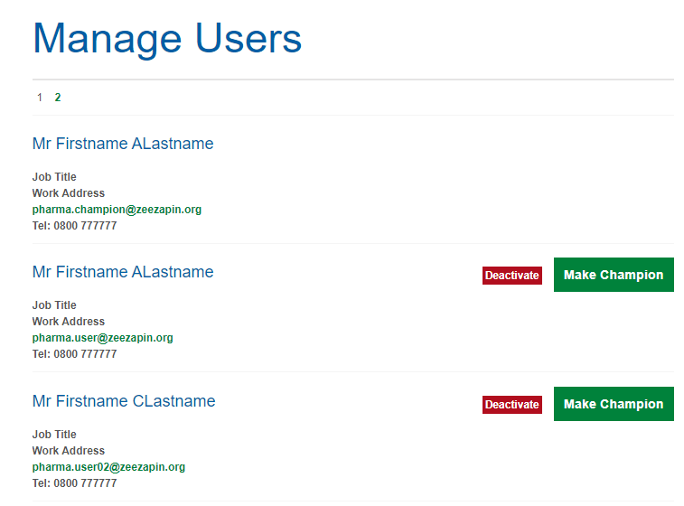

- To deactivate an account click Deactivate next to the user details.

- To activate an account click Activate besides the user details.

- To promote a Standard User to a Champion User, click Make Champion next to the user details.

- To remove Champion User permissions from a Champion User, click Remove Champion next to the user details.

Managing Company Details

You can edit all company details on the Manage Company Details form.

- Click Manage Company Details.

- Edit details.
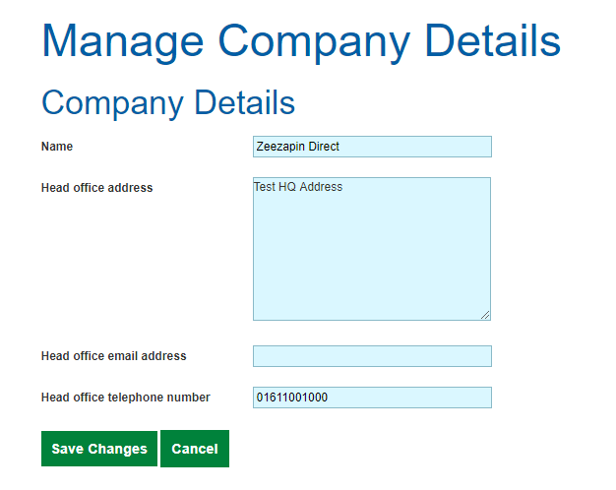

- Click Save Changes.

Your updated information will now be displayed on the Company Administration page.

Appendix 1: UK PharmaScan - Fields

Field Name | Mandatory | Help Text | Comments
Drug
Manufacturer | Automated
Branded Name
Generic Name | Yes | For combination products, please enter all non-proprietary drug names into the 'Generic name' field.
Synonyms
Indication
Proposed | Yes | Example 1  Drug A, for use in combination with drug B and drug C in adult patients with HER2-positive metastatic or locally recurrent unresectable breast cancer, who have not received previous anti-HER2 therapy or chemotherapy for their metastatic disease.  Example 2  Drug A, in combination with drug B, for the treatment of moderate to severe active rheumatoid arthritis in adults when the response to disease-modifying antirheumatic drugs, including drug B, has been inadequate.
Final |  | Example 1  Drug A, for use in combination with drug B and drug C in adult patients with HER2-positive metastatic or locally recurrent unresectable breast cancer, who have not received previous anti-HER2 therapy or chemotherapy for their metastatic disease.  Example 2  Drug A, in combination with drug B for the treatment of severe active rheumatoid arthritis in adults when the response to disease-modifying antirheumatic drugs, including drug B (unless contraindicated), has been inadequate. | Final description of the indication  To be completed when marketing approval is obtained
Abbreviated | Yes | Example 1  Breast cancer, metastatic or unresectable HER2-positive, with drug B and drug C (CLEOPATRA)  Example 2  Rheumatoid arthritis, moderate to severe, with drug B
Identified sub groups
Proposed place in therapy | Yes | Example 1  first-line  Example 2  second-line or greater | Description of the line of the therapy
Stage of disease
Is paediatric |  | The drug has been developed for use in children only, or children too. | Yes/No/Unknown
Formulation
Formulation | Yes |  | Selected from drop-down list
Details
Mode of action
Technology status | Yes |  | Selected from drop-down list
Nature of SPC amendment |  | Specify the section of the Summary of Product Characteristics (SPC) and state the change in full. If the change is to section 4.1, the technology status should be "New indication" rather than "Amendment to SPC with no change to licensed indication".
Route | Yes |  | Selected from drop-down list
Presentation
Proposed dose
Proposed dosing regimen
BNF Chapter |  | Only a single BNF classification value may be entered. | Selected from drop-down list
Disease state |  |  | Search and select from the disease ontology List available on request
Is the drug considered a personalised medicine? |  | Choose the relevant response to indicate whether or not the drug takes account of a person’s genes, health, and environment. | Yes/No/Unknown
Is there a companion diagnostic test? | Yes
Please provide details
Current treatment options
Likely comparators
Has this medicine been formally selected for an AWMSG TDA? |  |  | Yes/No/Unknown
Comments
Has this medicine been formally selected for a NICE HTA? |  |  | Yes/No/Unknown
Comments
Will this medicine be appraised by the SMC? |  |  | Yes/No/Unknown
Comments
Who is the originator company? |  |  | Selected from a drop-down list of companies registered with UK PharmaScan
Originator company name |  |  | Only used if Other entered for previous field
Is the drug being co-marketed? |  |  | Yes/No/Unknown
Co-marketing company |  |  | Selected from a drop-down list of companies registered with UK PharmaScan
Co-marketing company name |  |  | Only used if Other entered for previous field
Clinical trial information |  |  | Details of multiple trials can be included
Study name |  | Please provide details of any study name/acronym that the trial can also be identified by e.g. ADES, ELIOS.
National Clinical Trial number from ClinicalTrials.gov |  | Please enter the ClinicalTrials.gov identifier number which starts NCTXXXXXXXX - the system will use this to automatically create a link to the relevant trial on the ClinicalTrials.gov website. Please do not enter any other type of study code or information in this field as this will result in a broken link.
Trial number from other clinical trial registry |  | If the trial is listed in another clinical trial registry such as the International Standard Randomised Controlled Trial Number (ISRCTN) or the EU Clinical Trials Register (EudraCT) number, the number may also be included here.
Publications |  | Within this section there is the opportunity to include details of relevant publications, press releases and abstracts for the interim and final results of this trial. For publications the full reference details should be provided (in the Vancouver style) along with a DOI reference and/or a web address to the relevant journal. | With web links where available
Regulatory information
MHRA status
MHRA regulatory procedure | Yes | Please see MHRA website for the latest information on the MHRA regulatory procedures. | Commercial in confidence field  Selected from drop-down list whose values include:  - Unknown/ Other (please provide details)  - International Recognition Procedure - European Union as reference regulator  - International Recognition Procedure - United States as reference regulator  - International Recognition Procedure - Australia as reference regulator  - International Recognition Procedure - Canada as reference regulator  - International Recognition Procedure - Japan as reference regulator  - International Recognition Procedure - Singapore as reference regulator  - International Recognition Procedure - Switzerland as reference regulator  - MHRA national assessment procedure - accelerated  - MHRA national assessment procedure - standard  - EC decision reliance procedure  - EU mutual recognition reliance procedure  - EU decentralised reliance procedure  - Rolling Review Procedure  - Access Consortium  - Orbis
MHRA regulatory procedure details |  |  | Commercial in confidence field
Estimated UK regulatory submission date (quarter) | Yes | All estimated dates are commercial in confidence | Commercial in confidence field  Date must be less than Estimated UK licence date and Estimated UK availability date.  Value struck-through once Actual UK regulatory submission date is complete.
Estimated UK regulatory submission date (month) | Yes | All estimated dates are commercial in confidence | Commercial in confidence field  Date must be less than Estimated UK licence date and Estimated UK availability date.  Value struck-through once Actual UK regulatory submission date is complete.
Estimated UK licence date (quarter) | Yes | All estimated dates are commercial in confidence | Commercial in confidence field  Date must be same as or less than Estimated UK availability date.  Value struck-through once Actual UK Licence date is complete.
Estimated UK licence date (month) | Yes | All estimated dates are commercial in confidence | Commercial in confidence field  Date must be same as or less than Estimated UK availability date.  Value struck-through once Actual UK Licence date is complete.
UK conditional approval anticipated |  | Conditional approval is based on reduced clinical data, valid for 1 year (can be renewed) with obligation for ongoing studies | Commercial in confidence field  Yes/No/Unknown
Estimated UK availability date (quarter) | Yes | This is the estimated date the product will be made available in the UK for supply against a prescription.  All estimated dates are commercial in confidence | Commercial in confidence field  Value struck-through once Actual UK availability date is complete.
Estimated UK availability date (month) | Yes | This is the estimated date the product will be made available in the UK for supply against a prescription.  All estimated dates are commercial in confidence | Commercial in confidence field  Value struck-through once Actual UK availability date is complete.
Actual UK regulatory submission date |  | Date on which regulatory dossier was sent to UK regulatory agency. | Commercial in confidence field
Actual UK licence date
Actual UK availability date |  | This is the date upon which the product is made available in the UK for supply against a prescription - the technology entry will be archived 90 days from this date. | Record will be archived 90 days from this date
MHRA Promising Innovative Medicine (PIM) designation granted? |  | The Early Access to Medicine Scheme (EAMS) is a voluntary MHRA regulated process that allows patients in the UK access to drugs intended for life-threatening or seriously debilitating conditions that do not yet have a marketing authorisation when there is a clear unmet need. It is a two-stage evaluation process. Step I involves receiving a Promising Innovative Medicines (PIM) designation. This will give an indication that a drug may be eligible for EAMS based on early clinical data. Following designation the applicant is expected to complete a clinical development programme within a reasonable time period in order to progress to Step II, where the MHRA issue a scientific opinion on the benefits/risk balance of the drug. The opinion (which lasts for 1 year and can be renewed) supports the prescriber and patient to make a decision to use the drug before its licence is approved and does not replace normal licensing procedures. | Commercial in confidence field  Yes/No/Unknown
Estimated Early Access to Medicines Scheme (EAMS) submission date |  | As above | Commercial in confidence field
Actual EAMS submission date |  | As above | Commercial in confidence field
Estimated EAMS scientific opinion date |  | As above | Commercial in confidence field
Actual EAMS scientific opinion date |  | As above | Commercial in confidence field
EAMS scientific opinion decision |  | As above | Commercial in confidence field  Selected from drop-down list
International Status (IRP and pre-IRP EU)
Estimated International regulatory submission date (quarter) |  | All estimated dates are commercial in confidence.  This should be the date you plan to file to the International Reference Regulator that you selected in the MHRA regulatory procedure field. | Commercial in confidence field  Date must be less than Estimated International licence date  Value striked-through once Actual International regulatory submission date is complete
Estimated International regulatory submission date (month) |  | As above | Commercial in confidence field  Date must be less than Estimated International licence date  Value striked-through once Actual International regulatory submission date is complete
Estimated International licence date (quarter) |  | As above | Commercial in confidence field  Value striked-through once Actual International licence date is complete
Estimated International licence date (month) |  | As above. | Commercial in confidence field  Value striked-through once Actual International licence date is complete
International Fast Track application anticipated |  | This should relate to the International Reference Regulator that you selected in the MHRA regulatory procedure field. | Yes/No/Unknown
International conditional approval anticipated |  | Conditional approval is based on reduced clinical data, valid for 1 year (can be renewed) with obligation for ongoing studies.  This should relate to the International Reference Regulator that you selected in the MHRA regulatory procedure field. | Yes/No/Unknown
Actual International regulatory submission date |  | Date on which regulatory dossier was sent to regulatory agency. Date must less than ‘Actual International licence date’. This should be the date you filed an application for a licence to the International Reference Regulator that you selected in the MHRA regulatory procedure field. | Commercial in confidence field  Date must less than Actual International licence date
Estimated International opinion date |  | If applicable, this should be the date you estimate a recommendation to approve a licence will be issued by the International Reference Regulator that you selected in the MHRA regulatory procedure field, e.g. EMA CHMP opinion date.
Actual International opinion date |  | As above
International opinion |  | As above | Positive/Negative/Unknown
Actual International licence date |  | This should be the date a licence is issued by the International Reference Regulator that you selected in the MHRA regulatory procedure field.
EU status
Current EU stage of development | Yes | Please select current stage. After regulatory submission, please select the Pre-registration stage. | Selected from drop-down list
EU regulatory procedure |  | Please select the regulatory process being followed.  EU Centralised  This procedure results in a single marketing authorisation (called a 'Community marketing authorisation') that is valid across the European Union, as well as in Iceland, Liechtenstein and Norway. The centralised procedure is compulsory for human medicines that are: derived from biotechnology processes, such as genetic engineering; intended for the treatment of HIV/Aids, cancer, diabetes, neurodegenerative disorders or autoimmune diseases and other immune dysfunctions; officially designated 'orphan medicines' (medicines used for rare diseases).  EU Decentralised  The decentralised procedure enables a marketing authorisation for a medicinal product to be obtained in several Member States where it has not yet received a marketing authorisation at the time of application. The procedure varies depending on who initiates it, a Member State or the marketing authorisation holder.  EU mutual recognition  In the mutual-recognition procedure, a medicine is first authorised in one EU Member State (known as the reference member state),. Following this, further marketing authorisations can be sought from other EU countries in a procedure whereby the countries concerned agree to recognise the validity of the original, national marketing authorisation. | Selected from drop-down list
US status
Current US stage of development |  |  | Selected from drop-down list of US development stages
Response letter issued? |  |  | Yes/No/Unknown
Date response letter issued
FDA fast tracked? |  |  | Yes/No/Unknown
FDA orphan drug status |  |  | Yes/No/Unknown
General comments
Orphan Drug / ATMP categorisation
MHRA orphan drug status | Yes |  | Yes/No/Unknown
Date MHRA orphan drug status granted |  |  | Only visible if MHRA orphan drug status field is completed Yes
MHRA orphan status number |  |  | Only visible if MHRA orphan drug status field is completed Yes
Orphan drug status in EU | Yes |  | Yes/No/Unknown
Date EU orphan drug status granted |  |  | Only visible if Orphan drug status in EU field is completed Yes
EU orphan status number |  |  | Only visible if Orphan drug status in EU field is completed Yes
Classified as an Advanced Therapy Medicinal Product (ATMP) in EU |  | Please indicate if the European Medicines Agency (EMA) has agreed that the medicine is an advanced therapy medicinal product (ATMP), the type of ATMP and the date that the decision was made. | Yes/No/Unknown
ATMP classification |  |  | Only visible if Classified as an Advanced Therapy Medicinal Product (ATMP) in EU field is completed Yes  Selected from drop-down list
Date of recommendation on classification of ATMP |  |  | Only visible if Classified as an Advanced Therapy Medicinal Product (ATMP) in EU field is completed Yes
MHRA / international regulator Withdrawal, Suspension of Discontinuation status
Withdrawal date |  | This should relate to the International Reference Regulator that you selected in the MHRA regulatory procedure field.
Reason for withdrawal |  | Please state whether withdrawal is from MHRA, International Reference Regulator or both. | Only visible if Withdrawal date entered
Are there further plans for trials/refiling? |  |  | Only visible if withdrawal date entered  Yes/No/Unknown
If suspended, date of suspension |  |  | Record will be suspended from this date
Reason for suspension |  |  | Only visible if suspension date entered
If development is discontinued, date of discontinuation |  | The technology entry will be archived 90 days from this date. | Record will be archived 90 days from this date
Reason for discontinuation |  |  | Only visible if discontinuation date entered
If other reason for archival, date of decision to archive |  | If this record needs to be archived for a reason other than being discontinued or being made available in the UK, please enter the date and reasons.  Other reasons for archival include:  - Drug is not being taken forward in UK due to commercial reasons (but not available or discontinued)  - Drug has been out-licensed to another company  - Rights to drug have been returned to the originator company. | Record will be archived 90 days from this date
Other reason for archival
Cost and budgets
Proposed average dose
Place in therapy |  |  | Selected from drop-down list
Estimated length of treatment |  |  | Commercial in confidence field
Drug cost range (per patient per year or patient per episode if less than one year) | Yes | It is acknowledged that providing a cost estimate up to one year in advance of product launch is challenging. This is, however, an essential aspect of horizon scanning processes as financial planners use the cost projections to support the budget setting process. This is done in advance of the financial year in which the new product is likely to be launched.  Select a range representative of the estimated acquisition cost (or cost range) of the new product and the dosing regimen (or potential dose range) associated with this cost. If accurate estimates are unavailable, a range or ‘ball-park’ possible estimates are acceptable. Please indicate if the figures are accurate estimates or ball park figures in the free text ‘Drug cost notes’ field below.  If the ranges are too narrow, please enter your own cost range in the free text ‘Drug cost notes’ field below. | Commercial in confidence field  Selected from drop-down list
Drug cost notes |  | If ranges in previous field are too narrow, please enter your own cost range here (minimum and maximum values).  Please indicate if the figures are accurate estimates or ball park figures.  State clearly whether costs include or exclude VAT. | Commercial in confidence field
Is a Patient Access Scheme or alternative discount arrangement planned for this indication? |  | Patient access schemes are ways in which pharmaceutical companies can propose financial arrangements to enable patients to gain access to medicines. The Pharmaceutical Price Regulation Scheme 2014 makes provisions for companies to submit proposals for patient access schemes to the Department of Health. These schemes involve innovative pricing agreements designed to improve cost effectiveness and facilitate patient access to specific drugs or other technologies. Companies that are not part of the PPRS can submit proposals for similar alternative discount arrangements. Please add any additional detail to the ‘Comments’ free text field below. | Commercial in confidence field  Yes/No/Unknown  England  Wales  England & Wales  Scotland  Northern Ireland
Comments |  |  | Commercial in confidence field
Is the technology available on a compassionate basis pre-licence in the UK other than clinical trials? |  |  | Yes/No/Unknown
Service impact |  | Please indicate what the potential impact (other than drug acquisition cost) of the new product may be to the NHS. For example, cost of testing or new equipment associated with its use; impact on staffing or service provision. Note whether the impact is expected to be significant.
Impact on patients and carers |  | Please provide information on potential health impact of the new product, in terms of quality of life and survival. Include such aspects as patient preferences, adherence and if possible consider the wider societal health impact of the therapy.
UK patient population range | Yes | Select a range representative of the UK patient population range of the new product. Please provide accurate estimates, along with additional information in the free text ‘UK patient population notes’ field below. | Selected from drop-down list
UK patient population notes |  | Where possible UK data should be used but if this is not available, English or Welsh data from reliable sources (e.g. guidance from the National Institute for Health and Care Excellence [NICE]) or Scottish data (e.g. epidemiology data from NHS National Services Scotland [NHS NSS] or Health Protection Scotland [HPS] or Welsh data (eg http://www.infoandstats.wales.nhs.uk/) should be used and extrapolated to produce estimates.  Information on the epidemiology of the condition obtained through a systematic search of the published literature can be used to check the estimates derived from these epidemiological data or may be used instead, if these data are not available. Please state reference sources used for epidemiological data.  Where the eligible population is estimated from an extrapolation of figures in published literature, population data should be taken from the latest mid-year population estimates.  Details should be provided for any complex calculations and any assumptions used in calculating estimated patient population should be outlined. | State reference sources used for epidemiological data
Estimated eligible patient population |  | Enter details of assumptions used to estimate the number of patients who would be eligible for treatment with the new product or licence. Enter details of any factors or issues that create uncertainty around the estimate of eligible population, for example limitations of data used to estimate mean patient numbers for a rare condition or disease; or potential disparity in the distribution of patients across the UK for rare diseases with a genetic component.  Please state any reference sources used and include details of any complex calculations.  One example given.
Is the drug likely to have a significant service impact? |  |  | Yes/No/Unknown
Please specify |  |  | Only visible if Is the drug likely to have a significant service impact? is completed Yes
Is the net budget impact for the UK greater than £5million at year 5? |  |  | Commercial in confidence field  Yes/No/Unknown
Estimated uptake |  |  | Commercial in confidence field  Only visible if Is the net budget impact for the UK greater than £5million at year 5? is completed Yes  State any reference sources used and include details of any complex calculations
Estimated net incremental drug acquisition costs per annum at year 1 and 5 |  |  | Commercial in confidence field  Only visible if Is the net budget impact for the UK greater than £5million at year 5? is completed Yes
What will be the net budget impact at year 1 and 5? |  |  | Commercial in confidence field  Only visible if Is the net budget impact for the UK greater than £5million at year 5? is completed Yes
Budget impact model available from the company on request |  |  | Only visible if Is the net budget impact for the UK greater than £5million at year 5? is completed Yes  Yes/No/Unknown

Appendix 2: UK PharmaScan – Dropdown response options

The tables below provide the response options for fields in UK PharmaScan which use dropdown lists in the following sections:
- Formulation
- Details
- Clinical trial information
- Regulatory information
- Cost and budgets.

Formulation | Details |  |  | Clinical trial information
Formulation | Technology status | Route | BNF Chapter | Phase
Buccal tablet  Capsule  Chewable tablet  Cream  Cutaneous solution  Dispersible tablet  Dry powder inhaler  Ear drops  Enema  Enteric coated tablet  Eye drops  Gel  Granules  Implant  Inhalation powder  Inhaler  Intra-articular injection  Intradermal injection  Intralesional injection  Intramuscular injection  Intra-ocular injection  Intrathecal injection  Intratumoural injection  Intrauterine device (when carrying drugs e.g. progesterone)  Intravenous infusion  Intravenous injection  Intravitreal injection  Iontophoretic transdermal system  Long-acting release (LAR) depot injection  Metered dose inhaler  Modified release capsule  Modified release tablet  Nasal spray  Nose drops  Ocular implant  Ointment  Oral formulation  Oral solution  Oral suspension  Oromucosal solution  Other  Parenteral formulation  Pessary  Powder for oral solution  Powder for solution for infusion  Powder for solution for injection  Sealant powder  Solid oral dosage formulation  Soluble capsule  Solution for nebuliser  Subcutaneous infusion  Subcutaneous injection  Sublingual spray  Sublingual tablet  Suppository  Tablet  Topical implant  Topical solution  Transdermal patch  Transdermal systems  Unknown at present | Biosimilar  New chemical / biological entity  New dosing regimen  New formulation  New indication  New presentation | Enteral  Inhaled  Parenteral  TBC  Topical | 1 - Gastro-intestinal system  2 - Cardiovascular system  3 - Respiratory system  4 - Central nervous system  5 - Infections  6 - Endocrine system  7 - Obstetrics, gynaecology, and urinary-tract disorders  8 - Malignant disease and immunosuppression  9 - Nutrition and blood  10 - Musculoskeletal and joint diseases  11 - Eye  12 - Ear, nose, and oropharynx  13 - Skin  14 - Immunological products and vaccines  15 - Anaesthesia | Phase II  Phase III

Regulatory information

MHRA regulatory procedure | ATMP classification (MHRA and EU) | EAMS scientific opinion decision | Current EU stage of development | Regulatory procedure | Development in the US
International Recognition Procedure - European Union as reference regulator  International Recognition Procedure - United States as reference regulator  International Recognition Procedure - Australia as reference regulator  International Recognition Procedure - Canada as reference regulator  International Recognition Procedure - Japan as reference regulator  International Recognition Procedure - Singapore as reference regulator  International Recognition Procedure - Switzerland as reference regulator  MHRA national assessment procedure - accelerated  MHRA national assessment procedure - standard  EC decision reliance procedure  EU mutual recognition reliance procedure  EU decentralised reliance procedure  Rolling Review Procedure  Access Consortium  Orbis | Tissue engineered medicinal product  Gene therapy medicinal product  Somatic cell therapy medicinal product | Positive  Negative | Phase I  Phase II  Phase III  Pre-registration  CHMP opinion  Licenced in member state  Approved in EU  Available in UK | EU Centralised  EU Decentralised  EU Mutual recognition | Phase II  Phase III  Filed  Recommended for approval  Approved  Launched  Not recommended for approval

Cost and budgets

Place in therapy | Drug cost range | UK Patient population range
Add on therapy  No other treatment apart from best support care  Other  Substitute | <£1,000  £1,000 and £5,000  £5,000 and £10,000  £10,000 and £20,000  £20,000 and £30,000  £30,000 and £40,000  £40,000 and £50,000  £50,000 and £100,000  >£100,000  Not known | Less than 1 per 50,000  Between 1 per 50,000 and 25 per 100,000  Between 25 and 50 per 100,000  Between 50 and 150 per 100,000  Between 150 and 250 per 100,000  Between 250 and 500 per 100,000  Between 500 and 750 per 100,000  Between 750 and 1,000 per 100,000  Between 1,000 and 1,500 per 100,000  Between 1,500 and 2,000 per 100,000  Between 2,000 and 3,000 per 100,000  Over 3,000 per 100,000  Not known

